Conversation w/CDC re: pts w/IDD (without Down Syndrome) and COVID-19 vaccination

From: Adriane Griffen <agriffen@AUCD.ORG>
Sent: Thursday, January 7, 2021 4:01 PM
To: Dawn Rudolph <drudolph@AUCD.ORG>; Rylin Rodgers <rrodgers@AUCD.ORG>
Subject: RE: patient tiers

Thanks, Dawn. I will pass this along to our emergency preparedness project officers, as well as the Emergency Operations Center disability inclusion staffer.

Adriane
Adriane K. Griffen, DrPH, MPH, MCHES®
Senior Director of Public Health and Leadership
Association of University Centers on Disabilities (AUCD)
1100 Wayne Avenue, Suite 1000, Silver Spring, MD 20910
240-821-9374 (VM) I 202-210-1546 (Cell) I agriffen@aucd.org I @adrianegriffen
AUCD: Facebook I Twitter

Chair, APHA Public Health Education and Health Promotion Section l Past Chair, Friends of NCBDDD l
Member, Downtown Silver Spring Rotary Club l Member, MD Public Health Association
Stay Safer at Home. Stay Healthy.
COVID-19 Emergency Response Information - National Center on Disability in Public Health
1 in 4 Americans has a disability - Public Health is for Everyone!
From: Dawn Rudolph <drudolph@AUCD.ORG>
Sent: Thursday, January 7, 2021 1:10 PM
To: Rylin Rodgers <rrodgers@AUCD.ORG>; Adriane Griffen <agriffen@AUCD.ORG>
Subject: FW: patient tiers

Hi there, sharing the below from Alice Kuo, LEND Director at UC LEND, who is challenged by administrators who are allowing ONLY her patients with Down Syndrome to get vaccinated and caregivers of people with IDD to get vaccinated. Other individuals with IDD who are also at higher risk are not allowed vaccination by their administrators, as the administrators are only following CDC guidance re: Down Syndrome and caregivers. This is leaving individuals with IDD unvaccinated, though they are at great risk as well. Alice is hoping this might be shared with CDC, letting them know this barrier exists – is that something you can help with?
Many thanks,
~ Dawn
From: Kuo, Alice <AKuo@mednet.ucla.edu>
Sent: Thursday, January 7, 2021 12:11 PM
To: Dawn Rudolph <drudolph@AUCD.ORG>
Subject: FW: patient tiers

Alice Kuo, MD, PhD, MBA
Professor and Chief, UCLA Medicine-Pediatrics
Director, UCLA Center of Excellence in Maternal and Child Health
Associate Director, UCLA Preventive Medicine
911 Broxton Avenue
Los Angeles, CA 90024
310-794-2202
Assistant: Madeline Haley mhaley@mednet.ucla.edu
From: Alice Kuo <AKuo@ph.lacounty.gov>
Date: Thursday, January 7, 2021 at 7:56 AM
To: "De St Maurice, Annabelle" <ADeStMaurice@mednet.ucla.edu>, "Rao, Lekha M.D." <LRao@mednet.ucla.edu>
Cc: "Alice Kuo, MD, PhD" <AKuo@mednet.ucla.edu>, "Nunez, Denise M. MD" <DMNunez@mednet.ucla.edu>
Subject: Fw: patient tiers

CAUTION - EXTERNAL EMAIL:Do not click links or open attachments unless you recognize the sender.
Hi Annabelle,

I am a primary care provider for many ID/DD patients so their parents who are IHSS providers need to get the vaccine. I met with Lily Roh yesterday who said that only Down Syndrome patients could get the vaccine because this was listed on the CDC website, but how would we go about getting our parents who are IHSS providers vaccinated? Will I be able to order the vaccine and they can schedule?

https://www.cdc.gov/coronavirus/2019-ncov/need-extra-precautions/people-with-medical-conditions.html
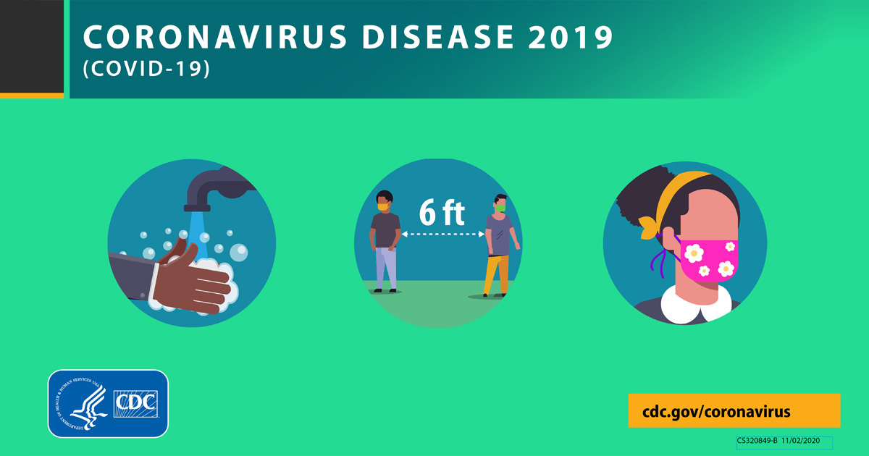 | Certain Medical Conditions and Risk for Severe COVID-19 Illness | CDC  Adults of any age with certain underlying medical conditions are at increased risk for severe illness from the virus that causes COVID-19. Severe illness from COVID-19 is defined as hospitalization, admission to the ICU, intubation or mechanical ventilation, or death.  www.cdc.gov
The corollary is that the recommendation is that all patients with ID/DD be vaccinated as well, so when these parents schedule, they will be asking on behalf of their child. To only restrict the vaccine to Down Syndrome is going to seem significantly limiting and potentially unfair. Lily said she sent the request to the command center but it was denied. Some of my parents are high profile employees (faculty, admin leadership) at UCLA so I just wanted to check before I sent them to County to get their vaccine.

https://www.nytimes.com/2020/11/10/health/covid-developmental-disabilities.html

https://ncd.gov/newsroom/2020/ncd-recommends-covid-19-vaccine-allocation-equity-individuals-idd

https://ddi.wayne.edu/aucd/covid19vaccine-idd-statement.pdf

https://ddi.wayne.edu/aucd/risk_factors_for_covid-19_mortality_among_privately_insured_patients_-_a_claims_data_analysis_-_a_fair_health_white_paper_11-9-20.pdf

Thanks,

Alice

Alice Kuo, MD, PhD, MBA
Professor and Chief, UCLA Medicine-Pediatrics
Director, UCLA Center for Excellence in Maternal and Child Health
Associate Director, UCLA Preventive Medicine
911 Broxton Avenue
Los Angeles, CA 90024
Tel: 310-794-2202
Assistant: Madeline Haley mhaley@mednet.ucla.edu
From: Nava Yeganeh <NYeganeh@ph.lacounty.gov>
Sent: Thursday, January 7, 2021 7:26 AM
To: Alice Kuo <AKuo@ph.lacounty.gov>; Naman Shah <NShah@ph.lacounty.gov>
Subject: patient tiers

Hi Alice,

Included are the providers that can sign up at PODS, which includes IHSS. For patients, they would maybe fit into Phase 1b. As far as I know, we haven’t diverted from CDPH’s algorithm.

Including Naman for all things related to vaccine. Naman, Alice is the head of Prev Med at UCLA and trying to get her IHSS patients on their list for vaccine.

http://publichealth.lacounty.gov/acd/ncorona2019/vaccine/HCWSignup/

https://covid19.ca.gov/vaccines/#When-can-I-get-vaccinated

Nava Yeganeh, MD MPH
Infectious Diseases, Medical Epidemiologist
Acute Communicable Disease Control Program
Los Angeles County Department of Public Health
nyeganeh@ph.lacounty.gov
Sent from Mail for Windows 10

