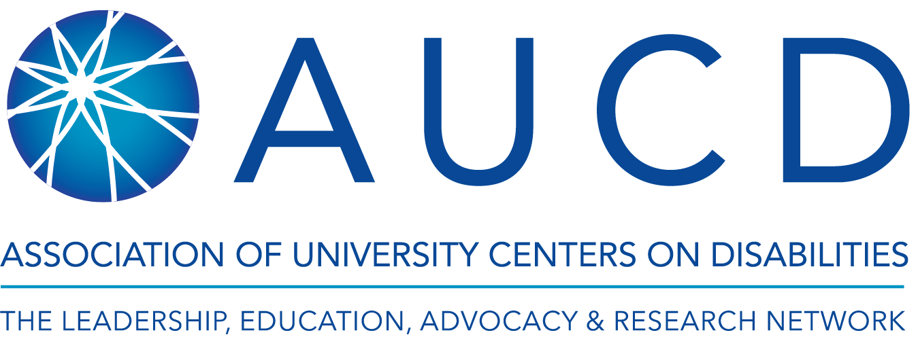

Update from AUCD
April 13, 2020
Association of University Centers on Disabilities (AUCD) staff has been actively monitoring and taking necessary steps to ensure continuity of operations as the Coronavirus (COVID-19) outbreak continues to develop. With your continued support, AUCD has been able to work with our staff, network, policy-makers and other stakeholders to provide up to date information, technical assistance, and guidance on the rapidly developing response and its impact on people with disabilities and their families.
We hope that AUCD and its vast network of centers and programs that are on the frontlines of the COVID-19 response can provide support to you through access to information on policies, practices and other resources during this unprecedented time. Please don’t hesitate to reach out to us at any time and we plan to send you a monthly update moving forward.
For our Staff
- On March 16th, we closed our Silver Spring office to become a wholly remote organization.
- In late March, we launched a newly authorized federal emergency leave policy.
- We are supporting our staff with flexible work hours and arrangements that meets the needs of their home/work life balance to accommodate the familial and health changes that they face.
- We continue weekly staff meetings remotely and have created an online platform for information sharing, resources, and critical documents to meet work and personal needs during this time.

For our Network
- This past month, AUCD quickly transitioned in-person conferences to hosting nationwide virtual events - UCEDD Directors' Retreat and TA Institute and Disability Policy Seminar. We were able to meet the needs of our network while delivering content interactively via webinars to several hundred participants. In April, we will host our annual AUCD Gala virtually.
- We continue to provide technical assistance to our centers to support them in meeting the needs of their state and local communities. AUCD hosts weekly virtual meetings for all directors of UCEDDs, LENDs, and IDDRCs to update them on national policy changes, federal agency guidance, and a space to share what they are learning, hearing, and doing in their respective states.
- AUCD has been working tirelessly to advocate for the disability community throughout this time. The policy team has been meeting virtually with congressional champions, federal agencies, and coalition partners to fight for legislative and administrative action that meets the needs of people with disabilities and their families. We hosted our first National Virtual Hill Day to engage our network in educating their members of Congress and their staff about the critical investments needed to support the lives of the disabled.

For our Partners
- AUCD has been providing critical technical assistance and support to our federal partners, including the Center for Disease Control and Prevention (National Center on Birth Defects and Developmental Disabilities), the Administration on Community Living, (Administration on Disabilities), and Health Resources and Services Administration (Maternal and Child Health Bureau). We are in continual communication with them to educate our network on the impacts of their grant work as well as providing guidance and expertise to meet the needs of people with disabilities around the country.
- AUCD is a member of several coalitions including the Consortium for Citizens with Disabilities (CCD) and the Leadership Conference on Civil and Human Rights. We continue to work in partnership with coalitions to elevate the needs of marginalized communities during this global public health crisis. We have signed on to countless letters sent to Congress, the Executive Branch, and federal agencies urging for all response efforts to include people with disabilities.

For our Donors
- AUCD has continued to ensure ROI and opportunities for its sponsors and charitable givers through:
  - Visibility on the AUCD For All Gala website, planned social media recognition and acknowledgments during the virtual event.
  - Sponsor and exhibitor opportunities posted for the AUCD 2020 Conference taking place December 6-9 and a listing of already committed sponsors for that event.
  - List of ways to give on AUCD’s Donate page with a link to our list of sponsors in the AUCD annual report.

