#WhatWeNeed #WeaAreEssential

We are hearing each day from people with disabilities across the nation around the impact.  The fourth relief package for COVID-19 needs to include people with disabilities. Today we share the story of XXX:

California:

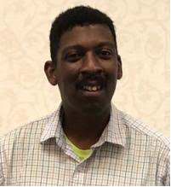My name is Wesley Witherspoon I am person with a disability. I work at University Center of Excellence in Developmental Disabilities at Children's Hospital Los Angeles, CA. Unfortunately, I lost my uncle to COVID 19. I am working to make people with disabilities lives better. This virus is real, I know other people who lost loved ones to COVID 19. Can you please help people with disabilities with COVID 19?

Florida: (sorry this image sucks – that’s what they gave us)

My name is Douglas Longhini and I am living with cerebral palsy. I am from West Kendall, Florida. The COVID-19 emergency has stopped many services including things that we take for granted like restaurants and malls. I am worried about those whom live with a disability who tend to be introverts. I know you are working on the fourth relief package for COVID-19. However, my concern is towards those who are shy and timid and may not be able to speak up about their loneliness during this time. How are you planning to remedy this? I urge you to take this seriously because in many cases this could lead to more depression and anxiety. Which at this time is dangerous and needs to be addressed.

Georgia:

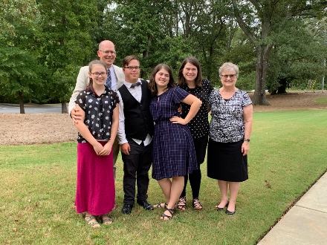My name is Stephanie Meredith and I am the mother of a 20-year-old young man with Down syndrome, Andy.  We are from Canton, GA. Andy is an Eagle Scout, a high school graduate, and is usually an active member of our community. Before the COVID-19 emergency, he was volunteering in local food pantries about 18 hours per week, coaching lacrosse at the local high school about 10 hours per week, working 5-10 hours per week at the local grocery store, and starting a career as a photographer and just launched his website.

The COVID-19 emergency has made it unsafe for him to continue working at his grocery store job and food pantries, the lacrosse season was cancelled, and he is selling very few photos with people needing to be conservative with their money. In addition, he has lost his community support staff member who helps him develop life skills because she is no longer able to visit our home.

Idaho:

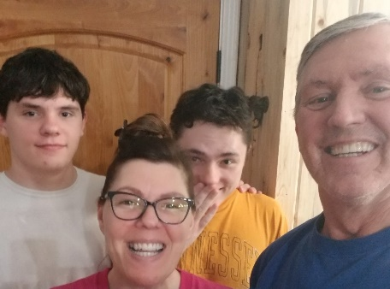My name is Tanya Samuelson and I am the mother of two boys Ryder & Bryton with autism in Meridian, ID.  The COVID-19 emergency has had a huge impact mostly on my 15-year-old Bryton.  He is a very structured and routine person.  Making changes to how things are done or where can be a huge struggle for him.  He is not able to go out in the community with his staff.  I see how stressed he is every day and I am not sure exactly what all he is thinking about.  I know the other day he stated that he is disappointed.   It is so important for people to understand that for those with a disability it is very difficult to just change how they do things!  So we are experiencing a major transition that even when we get to go "back to normal" that will be a transition as well.

Maryland:

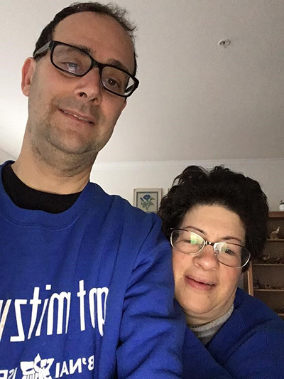My name is Phil Weintraub and I am a person with an intellectual and developmental disability. I am from Rockville, Maryland. COVID 19 has me working from home and making food shopping a bit of a challenge. I am worried that me or a family member will die. My name is Liz Weintraub and I am a person with an intellectual and developmental disability. I am from Rockville, MD. The COVID-19 emergency has me working from home. I am worried about getting help from staff coming into my home while "stay home, saves lives." I need information about COVID-19 to be in plain language as its hard for me to understand and feel safe during these hard times if information is not accessible.

New York:

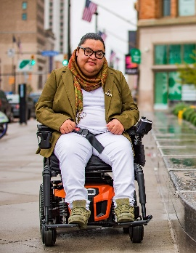My name is Jeiri Flores and I am a person with a physical disability; I have cerebral palsy. I am from Rochester, New York. The COVID-19 emergency has not only changed my everyday life it has changed how I interact with my respite staff and health care aides.

I am worried about my job and what employment for people with disabilities will look like post COVID-19. My role as an advocate is unorthodox and untraditional so there’s little to no protection or job security. Specifically, I am concerned that the job I fought for years to obtain is in jeopardy and I’ll once again be at the mercy of the complex reality that is job searching while disabled.

Ohio:

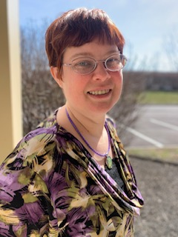

My name is Christine Brown and I am a person with disability. I am from Columbus Ohio. The COVID-19 emergency because of social distancing has stopped me from getting to do my usual stuff. I do like getting to go out in the community and my staffing has been reduced. I am worried about this going on past summertime and how will states be able to keep services running with the tight financial budgets. I also have limited staffing. I have gone from 16 a week to average of 8 due to the limit of not being able to go places. We also want our Direct support professionals to be paid more during this crisis because they are working hard. I need information about COVID-19 to be in plain language as its hard for me to understand and feel safe during these hard times if information is not accessible.