#WhatWeNeed #WeaAreEssential

We are hearing each day from people with disabilities across the nation around the impact.  The fourth relief package for COVID-19 needs to include people with disabilities. Today we share the story of XXX:

DC:

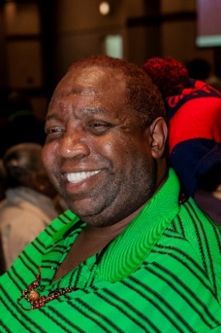My name is Thomas Mangrum, Jr. I live in Washington, DC in a senior citizens building. I have a disability and other serious medical conditions. I use a motorized wheelchair for mobility. I am a co-president of Project ACTION! an advocacy group in DC. Before the COVID-19 crises, I received personal support services from a direct service provider (DSP) five (5) days a week from 8am-4pm, but haven’t received services lately, except for 4-6 hours once every 2 weeks. I do still receive periodic visits from a nurse to monitor my medical conditions. I’ve been told that the DSPs won’t come to my home because I live in senior housing and they’re afraid of being infected with COVID-19. I feel very isolated.

Florida:

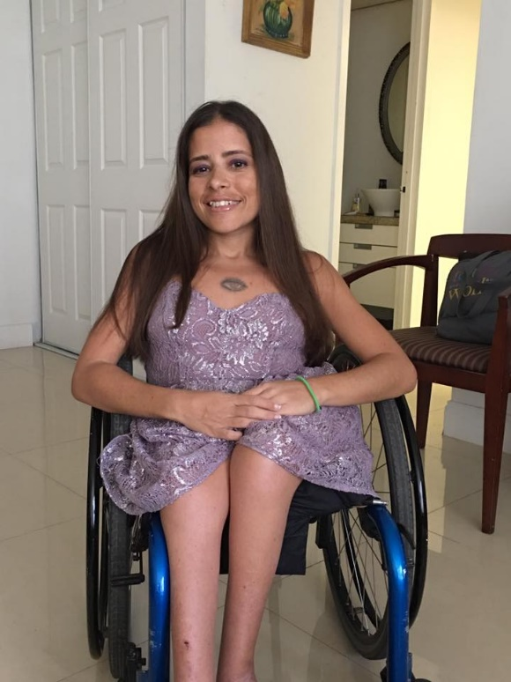My name is Mary Katherine Magnoli and I am a person with a physical disability. I am from Aventura, Florida. The COVID-19 emergency has me advocating from home. I am worried about this because I have devoted over a decade of my life to reaching as many people as I can. Now, with so many businesses closed, many of my projects are on hold making it hard for me to make an impact. Therefore I am only left with the option of speaking on my facebook page video and the occassional article opportunity to get my message across of inclusion and anti-bullying. These are unparalleled times where a person with a disability is being looked at very diferently since we are the one susceptible of this virus. Since the beginning of this pandemic I have noticed that more so than ever the perception society has on us has taken a very big downfall turn into fear.

Delaware/Texas:

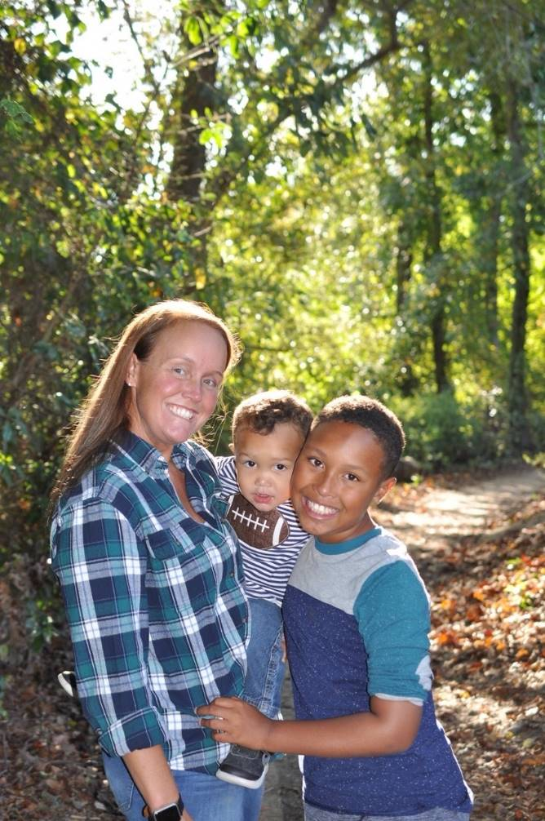My name is Mandelyn Chelsea Cook-Jones  and I am the mother of a ten year old child named Reagan, who is on the Autism spectrum. I am originally from Houston, Texas but being a sixteen year   Active Duty Airforce member I have been stationed at Dover AFB, Delaware for the past four years. The COVID-19 emergency has stopped all in school sessions, ABA services, Speech, and Occupational therapy and additionally rescheduling crucial in person doctors appointments for my son. I am worried about how much regression he will develop with the loss of services as some has already developed.  Things we have worked years upon years to help him with that are slowly starting to appear again; which I can only guess will get worse as time goes on.

Virginia:

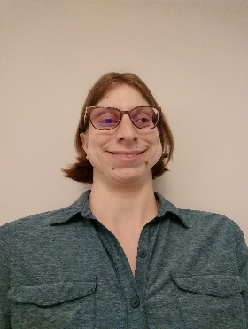My name is Lynne Fetter, and I am a graduate student with developmental and psychiatric disabilities. I am from Williamsburg, Virginia. The COVID-19 emergency means that I must attend school and my internship remotely, which disrupts my usual routine and impacts my mental health. The COVID-19 emergency also complicates my ability to access the healthcare I need. I am worried about how this crisis may affect access to crucial mental health services in the future, both for myself and others with psychiatric disabilities.

Maryland:

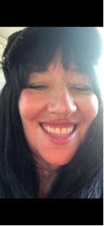My name is Sandra Bauman and I am a person with intellectual disability and significant somatic complaints. I am from Baltimore, Maryland. I live in my own home with some support services.  My needs are difficult. Finding an aide has been difficult.

I need information about COVID-19 to be in plain language as it’s hard for me to understand and feel safe during these hard times if information is not accessible.

New York:

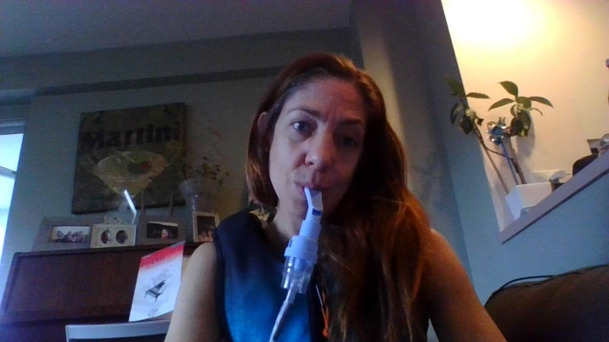My name is Melissa Shiffman and I am an adult with Cystic Fibrosis (CF) and a mother of a child with celiac disease. I am from New York, NY but am quarantined in NJ. The COVID-19 emergency has forced my family to vacate our home, as we live in a heavily populated apartment complex and the risk of COVID was too substantial to leave our apartment to use the garbage chute, the elevators, the laundry room, etc. I was also in the middle of a clinical trial for a groundbreaking CF drug and had to drop off because research visits were cancelled and I did not feel safe going to a lab for the testing required. I am worried about getting sick and not being able to access my CF specialist other than telemedicine. I worry that we have been having such a hard time getting gluten-free groceries delivered for my son. I am especially worried about state policies that value the lives on non-disabled individuals over those of us with pre-existing conditions. I worry that we will not be able to get home for a long time.

Illinois:

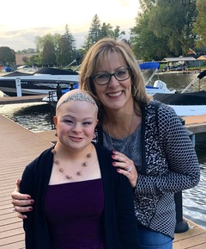 My name is Rebecca Newlon and I am a person with Down syndrome. I am from Bull Valley, IL. The COVID-19 emergency has stopped all in-person schooling, outside therapies (speech, physical and equine therapy), community and social events that help me become a more successful person. I am worried that I will lose some of my skills, especially conversational speech. I am 16 yrs. old and can only talk with my parents so much!