#WhatWeNeed #WeaAreEssential

We are hearing each day from people with disabilities across the nation around the impact.  The fourth relief package for COVID-19 needs to include people with disabilities. Today we share the story of XXX:

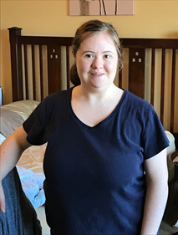My name is Rachel Mueller and I am a person with disability. I am from Sterling Heights, MI. I just lost my Grandpa to the Corvid 19 Virus. The COVID-19 emergency has stopped me from going to school and community-based instruction, workplace and community activities. Also, my direct support professional cannot come to my house. I also cannot schedule my hearing aid appointment. I am worried about going out into the community and staying safe. I am worried about being able to find a job. I know you are working on the fourth relief package for COVID-19. I want to learn more about how you are going to help people with disabilities in this package. Thank you very much for your time.

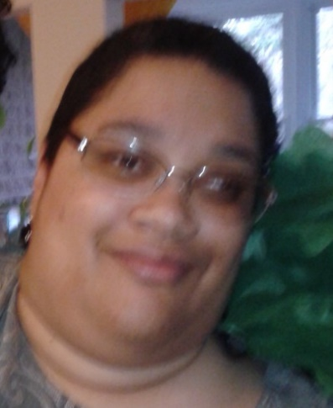My name is Kara Jones. I live in Silver Spring, MD with my family, and I’m a member several groups: Project ACTION!, People on the Go of Maryland, the Women’s Knowledge Group and Expectations Matter My Life, My Choice, My Plan. I have cerebral palsy and use a motorized wheelchair. I can’t go anywhere because everything is shut down, but I’ve been participating in Zoom meetings and birthday parties. But, I don’t know how to set it up and use it myself. Also, some of my friends don’t have the technology they need to connect with other people and cut down on their isolation. I worry about my health and my parents’ health because we are at high risk. And, I worry about what will happen if the people who care for me get sick.

As you prepare the 4th bill to address this pandemic, please consider ways to educate all people, especially people with disabilities about caring for themselves, staying safe and the importance of making other plans, if their care giver needs isolation. Then there would be no one to help you get out of bed, eat, dress and other important activities. Sometimes the words and announcements are too complicated to understand. Use pictures and “break it down!” Thank you.

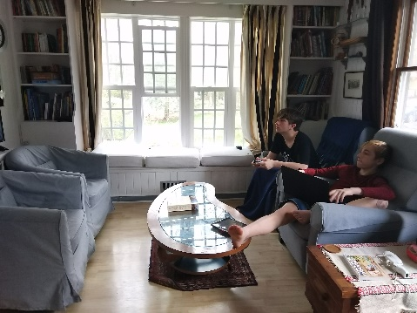 What Impact has Covid19 had on our family? My name is Paul Somerset and my husband and mine middle child has degenerative motor-neuron disorder as well as a brain malformation, and is just finishing four and half years of cancer treatment. Covid19 has stalled his treatments for four months. This is time has shortened his life. We live in the small town of Lewes, Delaware. Weekly we have to drive the length of our state for him to spend the night at the hospital. The Covid19 emergency means that this trip is no longer possible. We participate in tele-medicine but as he is the first person ever diagnosed with his specific motor-neuron disorder and the medical staff needs more hands-on appointment. With his compromised immune system this cannot happen. What this means is that every day the pandemic continues he is losing time exponentially at the end of his life. It means that he is not getting, PT, OT, and Speech. I means that he is losing functionality which he will never regain. My other fear is that our doctors are missing milestones in his degeneration. It is hard to watch your child fade, but our one constant hope has been that in his struggle other children can be helped in the future. So much of this work is now in jeopardy.  Thank you for the work you are doing on the fourth relief package for Covid19, and we and our extended family and friends support you. I would like to know more about how families with disabled children are being helped in this package.  Also, thank you for the time you are spending on supporting our family. I hope you and yours are well and stay that way.

anMy name is Bailey, and I am a person with a disability. I am from Mount Pleasant, Iowa. The Covid-19 emergency has cancelled a lot of activities for me. I didn’t get to enjoy my basketball game against the police department. I don’t get to go to CIP. I can’t see my friends or my boyfriend. I haven’t seen my family. I miss going to my day hab. I can’t leave the house to go. I miss going to work and I don’t get paid anymore. I want this virus to go away so I can go to back to work. I can’t get out of the house to do my grocery shopping. My staff shops for me but I am only able to get things I need because I don’t have a lot of money. I need to get back to work so I have money to buy food. I have stopped drinking pop to save money. I want this virus to go away so I can get back to my normal life again. I am sad that I am stuck at home and don’t get to go out into the community. I hope that this virus goes away so I can have a party for my birthday.

I know you are working on the fourth relief package for COVID-19. I want to learn more about how you are going to help people with disabilities in this package. Thank you very much for your time.

My name is Kelly Fritz and I am a physical therapist who works with children with disabilities. I am from Portland, Maine. The COVID-19 emergency has stopped physical therapy services for families without internet or resources. I am worried about loss of skills, negative health outcomes and the further increased wait lists when we return to work. I know you are working on the fourth relief package for COVID-19. I want to learn more about how you are going to help people with disabilities in this package. Thank you very much for your time.

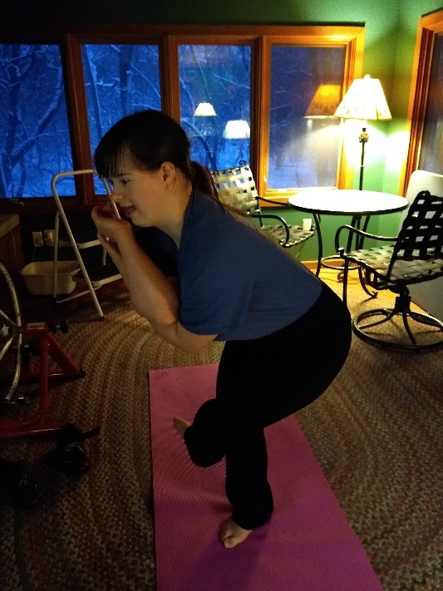

My name is Jean Hauff and I am a person with disability. I am from Minnetonka, MN. The COVID-19 emergency has impacted my education and employment. I am worried about how long distant learning will be. The COVID-19 has created uncertainty about when I will be able to go to college. I am not sure if I will continue my education through Transition next fall. It is hard to work on my reading and writing through distant learning.

I am also concerned about my employment opportunities. I was not rehired for my job with A Backyard Farm. The business is on hold due to COVID-19. My internship with Gale Woods Farm is on hold. The Farm has a hiring freeze and the employment plans are uncertain. I know you are working on the fourth relief package for COVID-19. I want to learn more about how you are going to help people with disabilities in this package. Thank you very much for your time.  

My name is Thomas “Alex” Harrison and I am a person with an intellectual disability (diagnosis of Autism). I am from Gulfport, Mississippi, but was born in Austin, Texas. The COVID-19 emergency has stopped me from going to school and engaging with my friends and interacting directly with my support teachers. I am worried about how people who have disabilities are coping during this crisis as there is so much misinformation and people are not used to staying home all the time. My friends with disabilities, especially intellectual disabilities and Autism, have a hard time with isolation and change. I worry about them getting what they need and still being part of their community. I know you are working on the fourth relief package for COVID-19. I want to learn more about how you are going to help people with disabilities in this package. Thank you very much for your time.