#WhatWeNeed #WeaAreEssential

We are hearing each day from people with disabilities across the nation around the impact.  The fourth relief package for COVID-19 needs to include people with disabilities. Today we share the story of XXX:

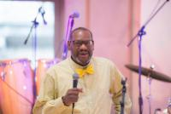 My name is Steven Powe. I live in Washington, DC. I have a disability and am employed at a Safeway grocery store in Washington, DC. I’m also a member of Project ACTION! – an advocacy group in Washington, DC. I have my own apartment and car and feel like I’m not impacted too much. I do realize that I’m taking a big risk working in a grocery store because of the spread of the virus. However, I am very concerned that many people with disabilities don’t understand the need for social distancing and the need to be very, very cautious when they go out or are around other people. As you prepare the 4th bill to address this pandemic, please consider ways to educate all people, especially people with disabilities about caring for themselves and staying safe from being infected from the COVID-19 virus maybe social stories. Thank you.

My name is Tomara Williams and I am a family member of a person with a disability. I am from Milford, DE. The COVID-19 emergency has stopped my son’s daily schedule for work and needed vocational services. I am worried about his regression on skills that required many years of therapy to bring us this far. I know you are working on the fourth relief package for COVID-19. I want to learn more about how you are going to help people with disabilities in this package. Thank you very much for your time.

My name is Gail Hamblin

Hello, my name is Lisa, and I am a person with a disability. I live in Burlington, Iowa. This virus has affected me in the sense that I am so bored and I can’t go where I want to. I can’t see my mom, I can’t get on the bus, I can’t go for walks to the gas station or to fun city, and I can’t go to dayhab. These were all things I enjoyed doing on a regular basis. I have felt more anxious and 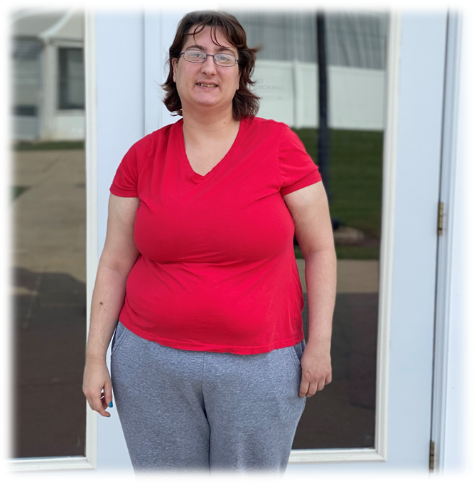have experienced some added depression because I am so bored and I spend a lot of time in my room. And the work, I used to have a job and a set schedule of when I worked and I miss not being able to work. Staff have to go shopping for me and there are many things I would love to buy, like CD’s, hair dye, pop and snacks. I can’t get any of the things I want, it is limited to the things I need. Please don’t forget about me when you are making decisions about how to help people through this virus.

**My name is Christopher C. Gagliardi. I am 39 years of age from Englewood, New Jersey and I am a person with disability which is Infantile Autism. Before this emergency, I was really making a strive forward towards a life that I want for me, I was back in college to get a degree in Journalism and I was really doing great, my mother was enjoying the quiet time away from me and to also have the independence to do what she needed to do, for she has a challenge herself, she has had to endure 4 bouts of cancer, spinal surgery and beyond which made have physical challenges too. I was also working at a coffee shop in my hometown making money for me to have fun and also to support my home. But ever since this pandemic came upon the shores, things have changed dramatically, as I am sure for all of us.**

**The COVID-19 emergency has made me leave the college for the time being and it has also made me be told to stay at home from work, because I was non-essential to the cause. I wanted to help in many many ways, but told, your not essential. I am worried about not having a job, not being able to pay for the important things that we need to survive in my home, we live on fixed income sincerely and this is really putting us in now a even tighter squeeze sincerely and it makes me sad deeply. I want this nightmare to end soon so that I can continue to move forward for my dreams to become true! I know you are working on the fourth relief package for COVID-19. I want to learn more about how you are going to help people with disabilities in this package, especially older folks who have disabilities on the spectrum past the age of 21 need help too. Thank you very much for your time**.

Hi my name is Alexis. I am 36 years old and I have a disability. I have staff that comes in to help me daily. Covid 19 is difficult for me because I am limited on the things I can do during the day, like going to my day program and community outings.

I live in Warren County Ohio I am afraid that if my staff gets sick, I will not get the necessary services I need.

I know you are working on the 4th relief package for COIVD-19. I want to learn more about how you are going to help people with disabilities in this package.  Thank you very much for your time.

Alexis A. Bodzin

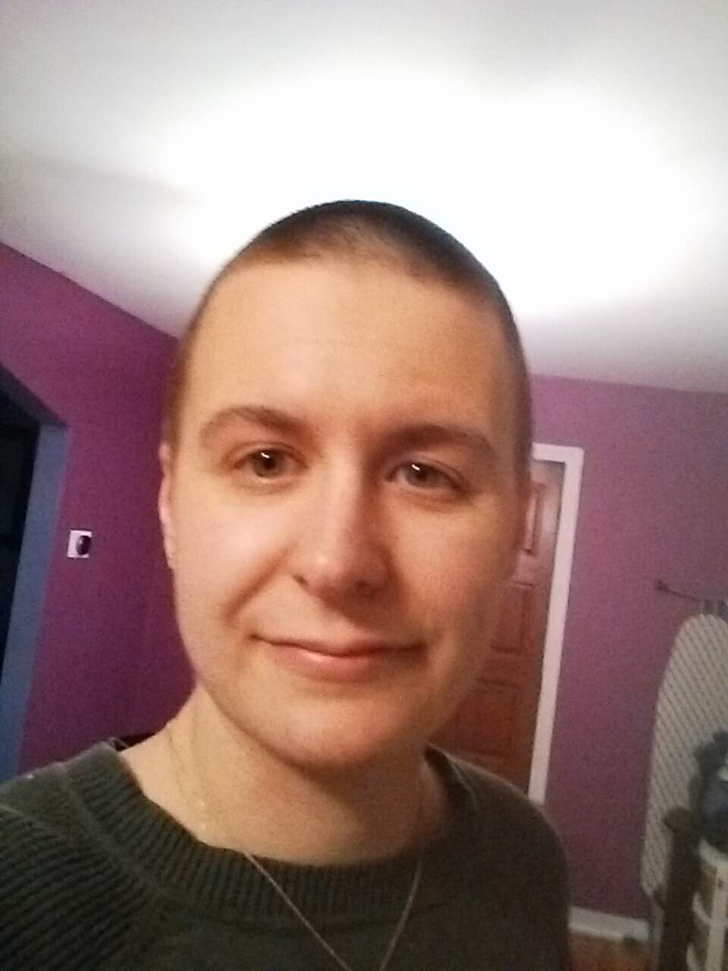My name is Angela Adler. I have chronic illness and PTSD. I am caring for my partner, who has a brain injury, through his brain cancer treatment. I am from Pittsburgh, Pennsylvania. Due to the COVID-19 emergency, my partner has been laid off. I work from home as a university professor. We are surviving on my graduate school stipend and unemployment compensation. My son had to go stay with grandparents because my partner and I are particularly vulnerable to the virus. Usually I get treated for my chronic illness every two weeks, but now my doctors won't treat me. The social isolation is also worsening my PTSD. I am worried that my chronic illness and PTSD will flare so badly that I won't be able to take care of my partner. I know you are working on the fourth relief package for COVID-19. I want to learn more about how you are going to help people with disabilities in this package. Thank you very much for your time.

My name is Mitch Simmons and I am a person with an intellectual disability, I am from Mechanicsburg, Virginia. The COVID-19 emergency has made it even harder for me to get services. I have anxiety and get very depressed and I cannot get a ride to get help or medication. I am worried about dying from COVID-19, my mom died last year. I am afraid and sad. People were coming to see me but now they do not. I am very lonely. I know you are working on the fourth relief package for COVID-19. I want to learn more about how you are going to help people with disabilities in this package. Thank you very much for your

My name is Nicole Silverman and I am a mother of a child with cerebral palsy and autism spectrum

disorder. My family is from Milwaukie, Oregon. The COVID-19 emergency has severely impacted access

to my son’s personal support workers (PSWs). As such, I am spending a great portion of my time

providing around-the-clock care for my child. This has personally impacted my employment status, and I

am not able to put time into my personal business and contribute financially for my family. In addition,

the COVID-19 emergency has limited my son’s access to his free and appropriate education. Many of the

activities that are sent to me by the school are not related to my child’s IEP or are not feasible with the

materials I have at home. The COVID-19 emergency has also caused distress regarding the availability of

my son’s life-essential medications. I am worried about the long-term effects of COVID-19 on my son’s

community participation. I know you are working on the fourth relief package for COVID-19. I want to

learn more about how you are going to help people with disabilities in this package. Thank you very

much for your time.