#WhatWeNeed #WeaAreEssential

We are hearing each day from people with disabilities across the nation around the impact.  The fourth relief package for COVID-19 needs to include people with disabilities. Today we share the story of XXX:

My name is Gail Hamblin and I am the mother of a family member with complex needs and disabilities. I am from Dover, Delaware. The COVID-19 emergency has stopped services (OT, SLP, PT, Doctor appointments, and for a while ABA) and caused a tremendous extra burden on our family. I am worried about finding proper milk alternatives to provide proper nutrition for my child due to his allergies and needs. I have spent countless hours on the phone and through email to coordinate healthcare and education for my child. I know you are working on the fourth relief package for COVID-19. I want to learn more about how you are going to help people with disabilities in this package. Thank you very much for your time.

(Sarah’s note: I don’t like this picture)

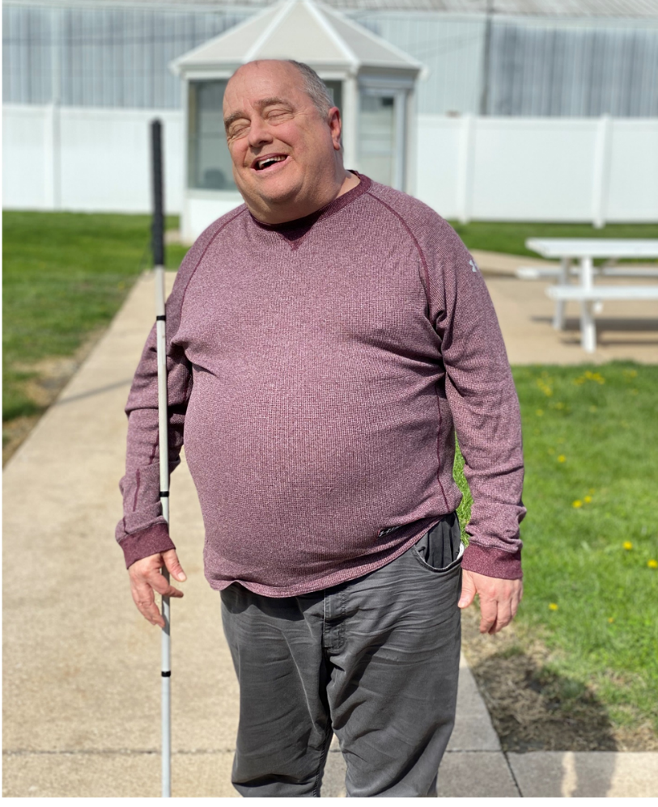My name is Terry and I live in Burlington, Iowa. The virus has impacted me in the sense that I have been experiencing more anxiety than usual because I am worried about my family. I am not able to see them and they can’t come visit. I have some depression because I haven’t seen my family since February. I have spring fever too, when it is very nice out, it is hard to accept the fact that I can’t go anywhere. I can’t buy anything I really want because staff have to go shopping for me and they aren’t able to go as often and are not able to buy things that non-essential. I haven’t been able to see my therapist or caseworker, all the “appointments” have been over the phone and that is very hard for me, I would rather be with them in person. Please don’t forget about me and my needs when you are deciding how to help people during this virus.

My Name is Kasse, and I am a person with a disability. I live and work in Mount Pleasant, Iowa. The COVID-19 emergency has stopped a lot of services for me. It isn’t letting me go to work. It won’t let me see my parents. I can’t see my boyfriend or my friends and I can’t go to places I want to go. I can’t drive anywhere without staff with me, and I have fewer staff to help me. I can’t go swimming. I am tired of being stuck in my house. I can’t go shopping because this virus is only letting certain people go into stores. I don’t like telling staff what I want, and want my staff to take me to the store, but they can’t. Staff goes shopping for me but only gets what I need. I want to be able to shop for what I want too. I can’t go out and do fun stuff. This virus makes me upset and sad. I’m worried about being able to go back to work, and being able to still get the support I need right now. I know you are working on the fourth relief package for COVID-19. I want to learn more about how you are going to help people with disabilities in this package. Thank you very much for your time.

The Virus is impacting my life because I am not able to go to work or go to choir rehearsal. I miss my friends and hanging out with my boyfriend. I am not able to go out in the community. I can only walk around the cul-de-sac.

I know you are working on the 4th relief package for COIVD-19. I want to learn more about how you are going to help people with disabilities in this package.  Thank you very much for your time.

Claire Ginn

**My name is Courtney and I am a parent of a child with disability. I am from Wilsonville, Oregon and what**

**worries me about this COVID-19 emergency is the exacerbation of already poor communication from**

**disability support agencies and the lack of financial assistance for families with disability. Since starting**

**shelter-at-home, we have stopped receiving essential services, such as feeding assistance, OT, and**

**PT. Prior to this emergency, we relied on the help of a village of people, who have all but diminished in**

**their capacity to support our family now. I am worried about the long-term stress that this will put on**

**myself and my partner, having to raise three children amid a global pandemic, with little support. I know**

**you are working on the fourth relief package for COVID-19. I want to learn more about how you are going**

**to help people with disabilities in this package--particularly, how will you ensure that families with**

**disability are being communicated with regarding all support services or funds available to them? Will**

**there be funds allocated for parents who are now assuming caregiving roles, at the expense of other**

**household or work duties? We thank you very much for your time and urge you to consider the pressing**

**needs of our most vulnerable.**

My name is Sheila Foglesong and I am a family member of a person with DD. I am from Rural Retreat, Virginia. The COVID-19 emergency has made it extremely difficult to find someone to be my son’s direct support staff. It was already a difficult situation and has been compounded by COVID-19. I worry about what will happen if I am helping him and I die, will anyone understand him if he calls 911? It is also very concerning to see states and medical personnel debate the shortage of medical supplies and who will be the recipient of available supplies. No one should have to make that decision outside of the family. I know you are working on the fourth package for COVID-19 and I want to learn more about what you are doing to help and protect people with disabilities. Than you very much for your time.