

My name is Taylor Carley and I am a person with an autism.  I am from Hattiesburg, Mississippi. The COVID-19 emergency has stopped me from working in the community and engaging as much with my friends and co-workers.

I am worried about how people with disabilities are coping as there is so much misinformation and people are not used to staying home. My friends with disabilities, especially intellectual disabilities and autism, have a hard time with isolation and change. I worry about them getting what they need and still being part of their community.

I know you are working on the fourth relief package for COVID-19. I want to learn more about how you are going to help people with disabilities in this package.  Thank you very much for your time.

My name is Alicia and I am the parent of two school aged children with disabilities. I am from Portland,

Oregon. The COVID-19 emergency has significantly impacted my children’s access to specialized education.

We have received distance learning materials from our school, however, without the structured routines of

their regular classroom, my children are struggling to maintain focus and engagement at this time. I am

worried about the long term impact this will have on their education and development. I know you are

working on the fourth relief packages for COVID-19. I want to learn more about how you are going to help

people with disabilities in this package. Thank you very much for your time.

I would like to remain anonymous and not disclose my name or location. As a person of color and an

immigrant, even though I am a LEGAL immigrant, I fear there may be repercussions for sharing my struggles. I

am a parent of a teenager with learning disabilities and emotional challenges. My partner and I do not speak

English fluently and have struggled with understanding how, when, and where to get appropriate support for

my child’s learning needs. Since my son was young, it was quite a challenge for us to secure help for his

learning given the cultural, language, and knowledge barriers. We did not know about or even heard of an

IEP. It took years for us to finally “catch up” and understand what types of rights we have. With the current

COVID-19 situation, we are struggling all over again. Also, with my child’s anxiety, coupled with the level of

discrimination Asian Americans have been receiving all over the country in New York, Texas, California, etc.,

ranging from receiving death threats to actual attempted murder, we are all struggling from crippling anxiety.

It is no longer a struggle only exhibited by my child. My entire family, neighbors, friends are all anxious and

living in fear. We want to know whether there is something being done to 1) help minority families like us

with learning about and accessing what is needed to support our child’s disabilities and 2) to protect

minorities from acts, especially threatening and violent acts, of discrimination. I know you are working on the

fourth relief package for COVID-19. I want to learn more about how you are going to help families like mine.

Thank you very much for your time.

Hi my name is JJ, I am a parent of three beautiful boys. I have 3 year old son with cystic fibrosis. I also have a

5 year old and a 9 month old. I am a father, a friend of people with disability, a family member of people

with disability, and an advocate for people with disability. I am a disability researcher and work with children

with hearing loss. The COVID-19 emergency has me worried. I just moved into a new house with my kids. I

need to work from home and make sure my kids are learning. I need to make sure my 3 year old receives his

necessary treatments daily. My child's lungs are affected by cystic fibrosis and he is at risk for lung infections.

I worry that my sons, my wife, or myself might catch COVID-19. Fortunately, we always take precautions and

do our best to keep our family as safe as possible. Like many parents, my biggest fear is that I will not be able

to provide my children with everything they need to be successful, happy, and healthy. I love my family so I

do everything I can to help keep them safe. I worry about COVID-19 putting my family at risk. I worry about

COVID-19 putting other families at risk and that we will not have the proper supports. I know you are working

on the fourth relief package for COVID-19. I want to learn more about how you are going to help people with

disabilities and their families in this package. Thank you very much for your time.

My name is Ed Gootzait. My daughter, Amy, is a person with an intellectual and developmental disability. Amy lives at home with my wife and me. Our family is under stress because we are all in vulnerable categories. We are doing “social distancing” and sheltering in place. However, someone has to sometimes go out to the store. We have been trying to keep Amy engaged and active throughout this time. This is becoming more difficult as the days pass. The COVID-19 emergency has eliminated all of Amy’s work, volunteer and day programs. Special Olympics has been cancelled her theatre program as well and working out at the gym. We are very concerned about the short-and long-term impacts of this crisis. A likely outcome will be a recession in the short-term and possible cuts in support services for years to come because of the budget impact at all levels of government. We do not know when her programs will restart or if they ever will come back at the same levels. We are very concerned that the COVID-19 support packages have not addressed the critical issues that are being faced by persons with disabilities and their family caregivers. These packages have not considered the financial needs of families that are the caregivers for their adult children. What would happen if caregivers such as us who are in the vulnerable age category become ill or pass away? I know you are working on the fourth relief package for COVID-19. I want to learn more about how you are going to help people with disabilities in this package. Thank you very much for your time.

My name is Kimi Hochstein, and I live in Townsend. Our 21 year old daughter, who struggles with social anxiety, along with her other chromosomal issues with PDD, has not been able to go to her job that she recently acquired through Thrive. She struggles with perseveration, so we use acrylic fake nails to prevent her from scratching herself. No nail salons are open so no fake nails, and her face and body look like she has the chicken pox. Her father is an ER doctor and our family is not coming in contact with him; he is self-quarantining. We see him at a distance but he is no longer in our normal household. Although communication regarding feelings are not a normal thing for her, I feel that the daily stress of the Covid news is impacting her, but thankfully because she is not social, this isolation is not as bad for her as neurotypicals and their need for peer connection. I know you are working on the fourth relief package for COVID-19. I want to learn more about how you are going to help people with disabilities in this package. Thank you very much for your time.

My name is Nancy Lemus. I am the parent of Christopher Garcia. He needs 24/7 care, and is vent trach and medically complex. This Covid-19 emergency has affected us severely. In one week we had 6 call outs from nurses. Parents of medically fragile children that need skilled care should be able to be paid for caring for their children. This would also free up nurses that need to be where the most vulnerable people are needed in this time of emergency. We could limit the traffic in our homes. These programs are available in other states. This emergency will make/is making nurse shortages more challenging to families like ours. I asked that our representatives in Congress make sure that people with disabilities in the community are also being counted for and that their supports are taken in consideration.

My name is Jody Hougentogler. I am from Smyrna, Delaware. My son is a severe brain injury survivor. He is a paraplegic. He has a tracheostomy, which at this time, does NOT require a ventilator. However, it requires 24/7 skilled nursing, along with some of his other medical issues. COVID-19 has brought a fear into our lives that we didn’t have before. If 2 or more of his nurses are unable to come to the house, he will have to go to the hospital. We have zero back up options, which is our biggest issue. The hospital may/may not be able to assist - and we don’t know what else we could do. The nursing agencies have no backup plan. So, while the rest of the world can stay in place without visitors, we have 8-10 nurses coming into our home weekly. The nurses are troopers and we’re all doing what is within our ability to protect our son, our family and their families as well. My hope is that emergency planning will look different in the future for those of us that are medically complex and living in the community.

The positive is that he can access his doctors via telehealth. That’s a big positive that I hope stays after the pandemic settles down. It is very difficult for us to travel an hour away for a doctor to just speak with me. Telehealth makes so much more sense in our world. I know you are working on the fourth relief package for COVID-19. I want to learn more about how you are going to help people with disabilities in this package. Thank you very much for your time.

My name is Sally Steggell and I am the mother of a 31 year old with Down syndrome and chronic asthma. I am from Wilmington, Delaware. The COVID-19 emergency has impacted the organizations my son relies on. Geoffrey is very social active, participating in programs with Special Olympics Delaware and the Down Syndrome Association of Delaware. Additionally, my son receives support from DDDS. He relies on his job coaches and the job coach programs. He is currently laid off from his job with the University of Delaware. I am worried about how of these vital programs may be impacted in the future. Once programs are back up and running, it will be extremely important to know the organizations support my son will be able to continue supporting their services. I know you are working on the fourth relief package for COVID-19. I want to learn more about how you are going to help people with disabilities in this package. Thank you very much for your time.

My name is Donna Aviles. My son James is 31 years old and a person with intellectual disability. He has a seizure disorder which, although it is under control with medication, he cannot be left alone due to a fall risk. James is nonverbal and typically goes out on a day program which is self directed by me. He has two community companions to take him to various locations on different days. Typically he would deliver meals on wheels, work in the laundry at Little Sisters of the Poor, deliver the daily schedule at Millcroft nursing home, go to the laundromat to do his wash, stock shelves at the Newark food closet, work in the laundry at faithful friends and visit the mall, parks, etc. Due to social distancing, James has had no support and no outside activities since March 12. In addition to his community companions, James would often have a home health aide for a few hours each weekend day and sometimes during the week. That has ended as well. A home health aide came to the house on Saturday March 14 and disclosed to me after she had been here a few hours that she had a temperature of 102 and did I have any Tylenol. I sent her home and have discontinued home health aides until further notice. James is now limited to things we can do here in the house and taking walks around the neighborhood and in local parks when they are not too crowded. We also take some drives in the car. While I have tried to explain to him what is going on, his understanding I’m sure is limited. He does FaceTime with his community companions and likes seeing their pictures on the phone but soon loses interest since they are not here to take him somewhere. A court order required him to go visit his father for the first two weeks of April. His father said he would follow social distancing guidelines but he does not share with me what is going on. I am praying that James comes back healthy. During the two weeks that James and I were social distancing, before his trip to his dad’s, it was becoming more and more difficult to keep him occupied and engaged. He was also starting to become a poor sleeper, probably from not getting enough activity. He is so used to being up and about. Moving from one activity to another, interacting with people in the community. Sitting in my small family room watching TV and playing simple games with me, taking walks and car rides... was becoming frustrating to him. I am sure he is wondering “where did my life go“… Like the rest of us I suppose. Even when social distancing is relaxed somewhat, I cannot imagine that James’ life - and by extension, mine - will resume as it once had been. Nursing homes will be off the list I’m sure, any place with large crowds or gatherings. I am not even sure at what point his community companions will feel comfortable coming back even on a part-time basis.

My name is Grace Wisnewski and I am a person with an intellectual and developmental disability. I am 16 years old and from Middletown Delaware. During the COVID-19 emergency I have had to adjust to remote learning from home for school and for my speech therapy services. I have been told I cannot socialize with family and friends outside my house. I am worried about how important parts of my life will be different when this is all over. In particular, I worry about my DDDS services. I will have a job when I graduate from high school and I will need a job coach. I also love Special Olympics.

I know you are working on the fourth relief package for COVID-19. I want to learn more about how you are going to help people with disabilities in this package. Thank you very much for your time

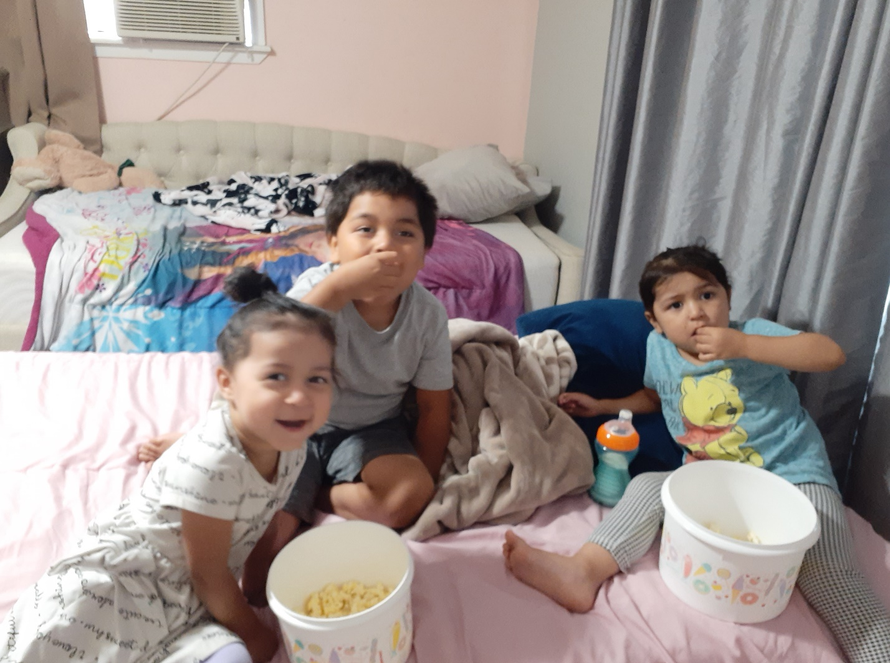My name is Sergio Zamarripa. I am 6 years old. My mom help to write this letter I have tyrosinemia type 1a rare disease and my sister Evangeline too. I have Asperger is very complicate learn to write and follow instructions I'm living in Houston Texas.  Since the COVID-19 My parents have not been able to pay the rent we moved it, and we are living in a room with a friend, because there is no work, I dream to have a room for me a my little sisters. I know you are working on the fourth relief package for COVID-19 I want to learn more about how you are going to help people with disabilities in this package. Thank you very much for your time.