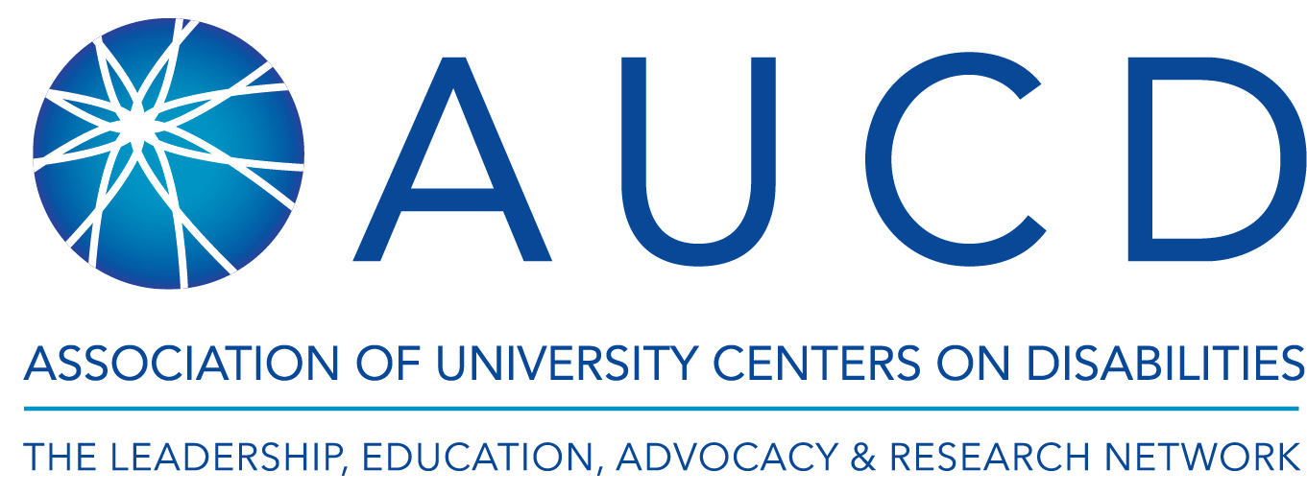

August 25, 2020
Dear Dr. Sabatello,
The Association of University Centers on Disabilities (AUCD) enthusiastically supports your grant proposal “People with Disabilities in COVID-19 Testing, Contact Tracing and Vaccines: Developing an Actionable Roadmap to Health Equity.” As we discussed during the grant’s development, the project engages people with physical, mental, intellectual/developmental, vision, and hearing disabilities to investigate the multileveled factors affecting uptake of COVID-19 testing, contact tracing and vaccination and to develop evidence-based strategies to enhance uptake of COVID-19 measures among people with disabilities.
AUCD is a membership organization that supports and promotes a national network of disability-based university-based programs located in every State and Territory. AUCD members engage in a range of interdisciplinary activities including exemplary services across the lifespan; basic and applied research; training and technical assistance to schools, communities, and governments; policy advocacy; program evaluation; and dissemination of best practices and new information. Among AUCD’s key initiatives is the National Center on Disability and Public Health, which uses evidence-based strategies to develop and increase the ability of public health professionals to include people who have disabilities. AUCD has been heavily involved in providing supports to its members and raising awareness of the needs of people with disabilities throughout the COVID-19 pandemic. AUCD has extensive experience in research collaborations and in conducting studies of its members and their partners and stakeholders numbering a few thousand people with various disabilities, including those intended for this study, across racial/ethnic and socio-economic groups. Thus, the recruitment of 4000 people with physical, mental, intellectual/ developmental, vision, and hearing disabilities for the online survey is highly likely. The proposed disability-accessible measures and online formats further make this study doable, as they remove numerous accessibility barriers that people with disabilities experience in clinical and other public settings and are tuned to the restrictions imposed by COVID-19. AUCD has full capabilities to collaborate with you on this study.
I confirm that the AUCD, through a designated representative, will work with you throughout the study. We will send invitations to participate in the online survey through its membership listservs; recruit 4 participants with physical disabilities to pilot test the survey instruments (2/cognitive interviews; 2/assess survey time completion)(year 1); and provide feedback on study material (animated educational material, survey) and outcomes throughout the study. We will participate in quarterly meetings (years 1-2) and 4 expert workshops with other partner national organizations of people with disabilities (with which we have had pervious successful collaborations) to develop disability inclusive strategies for COVID-19 mitigation plan (year 2). AUCD will also share the study’s findings with its members by posting briefs and organizing webinars with the research team. As we discussed, the AUCD will receive $2,000 in yr 1, and $3,000 in yr 2 for its work on this project.
The proposed study is the first comprehensive, national study to investigate the multileveled factors affecting uptake of COVID-19 mitigation measures among people with disabilities and to suggest remedies for barriers. The study is also a pioneer in its use of community-based participatory research approaches, attention to various disability subgroups as well as people with disabilities from racial/ ethnic minorities, allowing for systematic and comparative analyses, and adding to the scarce but critical work on the impact of marginalizations on uptake of public health measures during a pandemic.
We look forward to expanding our current collaboration with you and the network of national disability organizations to this new study, which we believe is highly innovative and of utmost importance for people with disabilities.

John Tschida, MPP
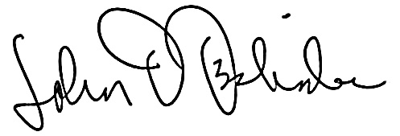
Executive Director

