**Addressing COVID-19 vaccine access and confidence among people with disabilities**  
*Due 3/3, Start 4/15, 1-year opportunity*  
AUCD is extending this subaward opportunity to your center/program through our AUCD-CDC cooperative agreement. This funding would begin during Year 3 of a 5-year cooperative agreement (6 NU38OT000280-03-02; CDFA No 93.421 - Strengthening Public Health Systems and Services through National Partnerships to Improve and Protect the Nation's Health). AUCD is a current CDC/Center for State, Tribal, Local, and Territorial Support (CSTLTS) grantee and is able to select members from its network with whom to partner on opportunities based on demonstrated experiences in the area of need for the opportunity.

**Background:**

-specifically written for AUCD to respond to (The target applicant is noted as: national network of AUCD's member centers in every state and territory, as well as key public health partners).   
-opportunity in AUCD’s current CDC cooperative agreement through CSTLTS  
-submission must be made through AUCD’s CSTLTS grantee portal  
-materials developed to be housed in AUCD’s Public Health is for Everyone online toolkit ([www.phetoolkit.org](https://nam04.safelinks.protection.outlook.com/?url=http%3A%2F%2Fwww.phetoolkit.org%2F&data=04%7C01%7Ckathleen.sheppard-jones%40uky.edu%7Cffa1f9c83e3746be422408d8d3619b7a%7C2b30530b69b64457b818481cb53d42ae%7C0%7C1%7C637491763470344836%7CUnknown%7CTWFpbGZsb3d8eyJWIjoiMC4wLjAwMDAiLCJQIjoiV2luMzIiLCJBTiI6Ik1haWwiLCJXVCI6Mn0%3D%7C3000&sdata=ufIRy5ADI9E90mOHcoSDDzX693CDrHhsqvNyDdK%2BGK8%3D&reserved=0))  
-CDC would like to have us approach this with a broad DD/cross-disability perspective so that the communications messaging and information disseminated would address barriers, co-occurring conditions, and cultural competency  
- AUCD is also exploring separate subawards with Human Development Institute, University of Kentucky UCEDD and the Green Mountain Self-Advocates to partner on adaptation of messages and materials into alternative formats, message development strategy, and dissemination

**Subaward SOW Summary:**

1. Participate in a national community of practice, which will meet regularly every 3-4 weeks via a virtual platform (Zoom)
2. Provide strategic advice during the CoP meetings and in between these meetings through subcommittees on topic areas, as determined by the group
3. Provide feedback on adapted materials. (AUCD will engage groups separately to develop these materials.)
4. Disseminate the adapted messages and materials in your region, either directly or through community partners or cultural brokers.
5. Share strategies and information with an AUCD-facilitated community of practice, comprised of 12 AUCD member center/programs across the country (DC, FL – Miami, OH – Cincinnati, NY Einstein, NY-WHID, NY-Rochester, MD, MT, NM, MN, PR, and SD)

**Budget:**

**$38,182** per AUCD member center/program, which includes:  
     $30,000 to dedicate to the community of practice collaboration  
     $7,722 (at AUCD’s federally allow indirect rate of 25.74%, per the terms of our cooperative agreement indirect rate agreement - attached)

AUCD will offer each center/program a trainee outreach stipend of $460. AUCD will administer this to a trainee of your choice (so we avoid further indirects).

***Opportunity Details in AUCD’s CSTLTS grantee portal***Project summary:   
This project aims to engage a national partner network to facilitate COVID-19 vaccine conversations among members, identify barriers to vaccine accessibility, increase vaccine confidence, share credible COVID-19 vaccination information, respond to misinformation, translate information into accessible formats, and share success stories and lessons learned. The applicant will work to advance policies and practices that improve the health, education, social and economic well-being of people with developmental disabilities and their families.   
  
Outcome measures include:   
Increased opportunities for vaccine collaboration among key public health partners,   
Increased access to COVID-19 vaccines,   
Increased trust and confidence in the COVID-19 vaccine, and   
Increased products translated and disseminated in alternative formats.

Programs and services opportunity –  
 *Activities:*

1.Collaborate with CDC and public health partners to have affective COVID-19 vaccine conversations, identify barriers to vaccine accessibility, and address vaccine misinformation among partners

2. Engage national network to make COVID-19 vaccine confidence visible, incorporating culturally appropriate approaches

3.Increase the capacity of their members to share credible COVID-19 vaccine information and respond to misinformation, conduct webinars using CDC provided resources, and regularly convene members to support each other and address vaccine barriers and challenges

4. Gather vaccine success stories from their membership and package them into formats for sharing throughout their network (e.g. ASL, braille, and extreme low literacy)

*Process measures:*

Number of barriers identified

Number of webinars and number of public health partners attending webinars

Number of regularly scheduled meetings and number of members participating

Number of success stories gathered and shared

Number of products translated and disseminated

*Outputs:*

Direct engagement with key audiences about vaccine barriers and confidence

Webinars to engage members and/or train them to have affective vaccine conversations

Communication strategy to make vaccine confidence visible and addressed misinformation

Collection of success stories and promising practices

Translation and dissemination of CDC approved products into alternative communication formats

*Budget Period Outcomes:*

Improved accessibility to COVID-19 vaccines and increased vaccine confidence among people with developmental disabilities and their families

*Outcome measures:*

Increased opportunities for vaccine collaboration among key public health partners

Increased access to COVID-19 vaccines

Increased trust and confidence in the COVID-19 vaccine

Increased products translated and disseminated in alternative formats

*This is a screen shot of the application in the AUCD-CSTLTS grantee portal:*

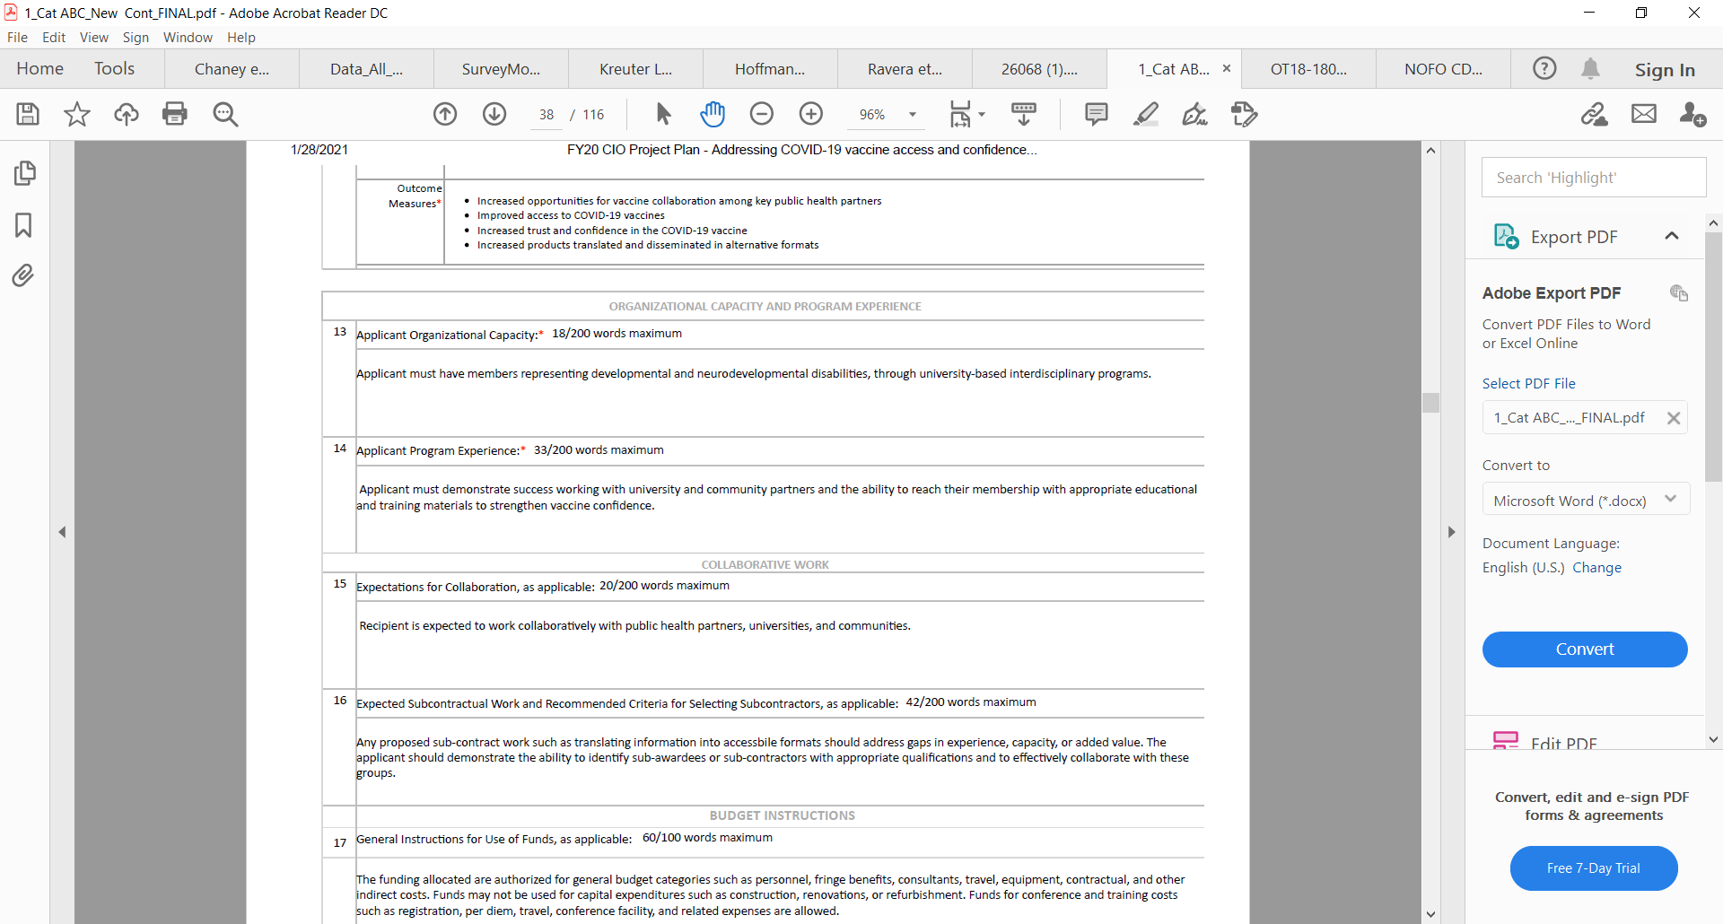

***On or before March 3, AUCD would need the following items:***

|  |
| --- |
| **Programs and Services:** Activities to improve the identification of best practices and the implementation of evidence-based/informed programs and services |
| **Describe the overall project approach, including the activities, outputs, performance measures (process and outcome), and budget period outcomes (shared above) related to the program strategy.** |
| **Activities**\* *List activities using the format: A1, A2, A3, etc. Use bullets* |
|  |
| **Process Measures**\* *List process measures using the format: PM1, PM2, PM3 etc. Use bullets* |
|  |
| **Outputs**\* *Use bullets to list outputs.* |
|  |
| **Budget Period Outcomes**\* *List budget period outcomes using the format: BPO1, BPO2, BPO3, etc. Use bullets* |
|  |
| **Outcome Measures**\* *List outcome measures using the format: OM1, OM2, OM3, etc. Use bullets* |
|  |
| **ORGANIZATIONAL CAPACITY\*** |
| Describe your plan for organization capacity as it relates to this project. Include specific organizations or entities as applicable. (1,500-1,800 characters max total) |
|  |
| **PROGRAM EXPERIENCE\*** |
| Describe your plan for program experience as it relates to this project. Include specific organizations or entities as applicable. (1,500-1,800 characters max total) |
|  |
| **COLLABORATIVE WORK\*** |
| Describe your plan for collaboration as it relates to this project. Include specific organizations or entities as applicable.  (1,500-1,800 characters max total) |
|  |

**Budget and Budget Narrative** – provide separately in Excel/Word, using the following categories:

|  |  |  |  |  |  |
| --- | --- | --- | --- | --- | --- |
| **BUDGET** | | | | | |
| **PERSONNEL SALARIES AND WAGES TOTAL** | (TYPE FIELD) | | **TRAVEL TOTAL** | (TYPE FIELD) |
| **FRINGE BENEFITS TOTAL** | (TYPE FIELD) | | **OTHER TOTAL** | (TYPE FIELD) |
| **CONSULTANT BENEFITS TOTAL** | (TYPE FIELD) | | **CONTRACTUAL TOTAL** | (TYPE FIELD) |
| **EQUIPMENT TOTAL** | (TYPE FIELD) | | **DIRECT COSTS TOTAL** | (READ ONLY) |
| **SUPPLIES TOTAL** | (TYPE FIELD) | | **INDIRECT COSTS TOTAL** | (TYPE FIELD) |
|  | | | | | |
| **GRAND BUDGET TOTAL** | | (READ ONLY) | | | |