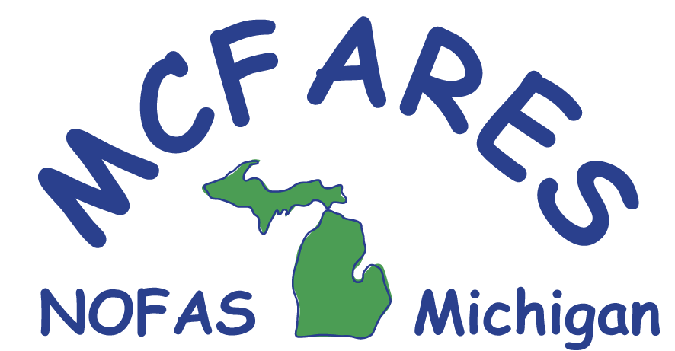

**Support Groups for FASD in Michigan**

**(not all groups are specifically for FASD support)**

(Please phone or email contact person prior to attending to ensure that group is still meeting. If information has changed, please email Charisse at Charisse@mcfares.org).

# Alpena County

FASD Family Support Group, Meets 3rd Wednesday of each month; 6:30 – 8 p.m., Thunder Bay Transportation Authority, 3022 US23 S, Alpena. Contact Mary Schalk at maryschalk@frontier.com 989-734-2877 for more information.

# Eaton County

Eaton County Foster Adopt Support Group, Meets 1st Thursday monthly, 6 – 8:30 p.m. Pot-luck dinner at 6:00 p.m. Group/training at 6:30 p.m. Childcare available. Eaton Intermediate School District, 1790 Packard Highway, Charlotte, MI 48813. Located right next door to Walmart. Contact Michelle for more information at besa_93@yahoo.com.

**Kalamazoo**

Now forming: Kalamazoo Area Fetal Alcohol Spectrum Disorder Support Group (KAFASD) for parents and guardians of children affected by FASD. Meets second Tuesday of the month at 6:30 pm at the Augusta McKay Library, 105 S. Webster Street, Augusta, MI 49012. Our mission: Cope with today. Hope for the future through encouragement, education, and resource sharing. For more information contact Robin or Kathy at [KAFASDgroup@yahoo.com](mailto:KAFASDgroup@yahoo.com).

# Kent County

West Michigan FASD Support Group, Meets 3rd Tuesday of each month, 7 – 8:30 p.m.,

Westminster Presbyterian Church, 47 Jefferson Avenue, Grand Rapids, MI 49503. Contact Sandy Kezenius, 616-874-9522; Corry Tait, 616-550-4273; or Barbara Wybrecht, 616-241-9126 or bmwybrecht@gmail.com for more information.

Self-Advocates with and FASD in Action (SAFA), generally meets on the 3rd Tuesday of each month. The meeting is for adults age 18 and up who have an official FASD diagnosis. Contact Rob Wybrecht for more information, rob1195@yahoo.com.

Adoptive Families Support Group, Meets 3rd Tuesday of each month, 6 – 8 p.m., Holy Family Catholic Church, 9669 Kraft Avenue SE, Caledonia, MI 49316-9723. Contact Shelley Garcia at

1-855-MICH-P2P, x705 or [sgarcia@afsn.com](mailto:sgarcia@afsn.com) for more information.

# Macomb County

Project SAFE (Supportive Activities for Everyone), Generally on a Friday or Saturday evening from 5:30 – 8:30 p.m. at various locations in Macomb County. Families meet for pot-luck dinner followed by supervised play for the children and support group time for adults. Contact Charisse at Charisse@mcfares.org or 586-329-6722.

Brunch Bunch, Monthly, 2nd Tuesday, 9 a.m. – 11 a.m., In Clinton Township, Contact Charisse at Charisse@mcfares.org or 586-329-6722 for location details.

**Muskegon County**

Support group for foster/adoptive/kinship families. Very active group meets weekly for various activities. Contact Janice Hilleary at [Bjhilleary@comcast.net](mailto:Bjhilleary@comcast.net) or 231-286-7892 (cell phone).

# Washtenaw County

Ann Arbor Support Group, Meets 4th Wednesday of each month except November (meets 3rd

Wednesday) and December (no meeting), 7 -9 p.m. St. Joseph Mercy Hospital, Education Center, Classroom #5, 5305 East Huron Drive. Contact Vern for more information at vsoden@umich.edu.

# On-line Support

Families and Supports Affected by FASD: http://groups.yahoo.com/group/FaSAFASD

*Note: no liability is assumed with respect to use of or inability to use the information contained in this newsletter. Although every precaution has been taken, the authors assume no liability for errors or omissions. No liability is assumed for damages resulting from the use of the information contained therein*

*Updated 8-24-16 AC*

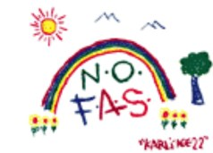

MCFARES is the Michigan NOFAS Affiliate